文件包含

———————————————————————————————————————

满足一些需求的变动性

printf("\n你确定要删除所有数据吗？(Y/S)\n");

scanf("%c", &judge);

judge = toupper(judge);

printf("输入你要修改的商品的名称：(输入\"back\"退出查找)\n");

scanf("%s", insert_name);

if (strcmp("back", insert_name) == 0)

{

return;

}

———————————————————————————————————————

初始化与存储！！

void init_itemdb(GoodsList **itemdb)

{

GoodsList *pitem;

FILE * fp;

bool res = check_nullfile(); //调用check_nullfile()函数检查文件是否存在或者是否为空

if ((fp = fopen(DATAFILE, "rb")) == NULL)

{

printf("商品信息初始化文件不存在！程序将为您新建一个.\n");

FILE *fp = fopen(DATAFILE,"w");

}

while (1)

{

if ((pitem = (GoodsList *)malloc(sizeof(GoodsList))) == NULL)

{

printf("Error in mallocating!\n");

exit(EXIT_FAILURE);

}

if (fread(pitem, sizeof(GoodsList), 1, fp) == 1 && res)

{

pitem->next = *itemdb;

*itemdb = pitem;

CurrentCnt++;

}

else

break;

}

printf("商品的链表文件已经建立，有%d条记录\n", CurrentCnt);

fclose(fp);

}

//-----------------------------------------------------------------

void save_and_exit(GoodsList ** itemdb)

{

FILE *fp;

if (itemdb == NULL)

{

printf("the linked list is empty!\n");

exit(EXIT_FAILURE);

}

if ((fp = fopen(DATAFILE, "wb")) == NULL)

{

perror("File open error:");

exit(EXIT_FAILURE);

}

while (*itemdb != NULL)

{

if (fwrite(*itemdb, sizeof(GoodsList), 1, fp) == 1)

{

*itemdb = (*itemdb)->next;

}

}

fclose(fp);

printf("\n|存盘成功！\n");

exit(EXIT_SUCCESS);

}

———————————————————————————————————————————————

重大的失误

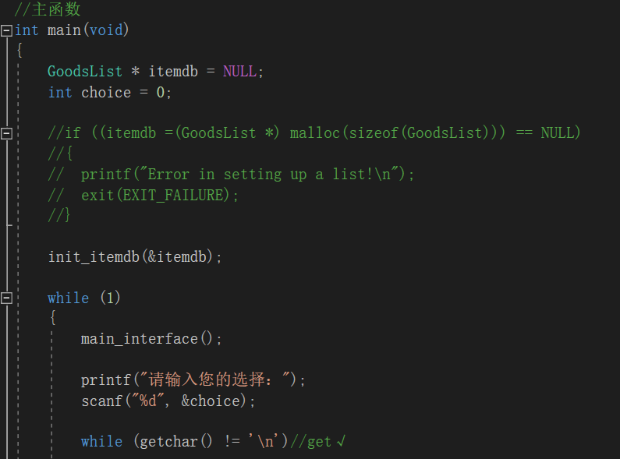

———————————————————————————————————————————————

界面设置的习惯

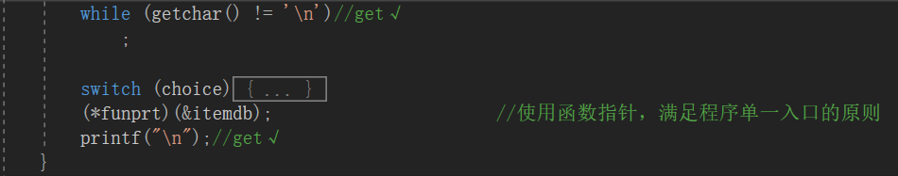

second = (*itemdb)->next;//优先级